Exploring Ageing:
Its effects on longevity of life & how it can be slowed.
* Reeva Chopra

Abstract:

This paper considers the inherent complexity of aging as separate from age-related diseases and appeals for an understanding of the fundamental biological processes that underlie life aging. The author identifies Leonard Hayflick's aging criteria as a vital universally manifested phenomenon while observing how aging reflects on every species post-reproductive phase, unlike diseases that may selectively act on subjects. The discussion extends to the accumulation of senescent cells, which compromise tissue function, and telomere dysfunction: an important aspect of cellular aging. The latest development in therapies, particularly CAR T cell treatments intended for attacking senescent cells, shows promise in treating issues of decreasing metabolism and declining physical performance as life progresses. Apart from this, the paper also challenges the idea of there being some genes, which would directly control aging. It says that though there are growth and development genes, they do not provide any blue print of how to age. This throws open an enquiry into the consequent effects of natural selection, as far as evolution is concerned it focuses more on how to replace the individuals of the current times rather than the prolonged survival of a long-lived individual once reproduction has been attained.
Ultimately, the paper concludes that incremental increases in human life expectancy are inadequate and provide little hope for effective strategies to slow aging and improve the quality of life of the elderly.
Thus a paradigm shift in biomedical research is advocated as more work should focus on improving functional longevity rather than merely prolonging life. This requires an integrated holistic approach to aging research that promotes quality of life to the elderly so that their years become healthier, longer, and more independent.

Keywords: Aging, Age-related diseases,. Biological processes, Leonard Hayflick, Senescent cells, Telomere dysfunction, CAR T cell therapy, Metabolism, Physical performance, Natural selection, Functional longevity, Biomedical research, Quality of life, . Elderly, Holistic approach

1.1 Introduction: What is ageing? Why discuss it?

While we've come a long way in understanding diseases related to ageing, like cancers, diabetes and COPD, we've haven't fully been able to understand the fundamental biological processes that cause ageing itself. If our goal is to extend human life, we must learn to treat two major questions as separate and essential, the first one being, "why do we age?" and the second one being " how long do we live?". But more importantly, instead of asking why we age, we should be asking why do we live as long as we do? If we want to extend human life beyond what we could achieve by simply curing today's major causes of death (like cancer and heart disease), we need to focus more on studying the deeper processes of aging.

Even today, the difference between the study of ageing (biogerontology) and study of diseases related to ageing (geriatric medicine). Ageing is often considered as a disease, but it really is not. Therefore, curing diseases related to ageing will not lead to a deeper understanding on ageing, all that it will result in would be an increase in 15-20 years of life expectancy. After which the leading cause of death would be ageing itself.

1.2 Hayflick's explanation of "The Future of Ageing":

There are four criteria as explained by Leonard Hayflick in his paper titled the future of ageing:
- Aging happens to every animal once it stops growing as an adult, while diseases don't affect everyone.
- Aging happens in almost all species, not just in humans or certain animals.
- Everyone in a species ages, but it only starts after they have passed their reproductive age (after having offspring).
- Aging still happens even to animals that are taken care of by humans and live in safe environments, even if that species hasn't aged for thousands or millions of years in the wild.

Therefore, from his findings it can be included that while ageing is a universal process which effects all animals in the ways explained above, while diseases affect selected individuals.

Death trends in older people

So, while people below the age of 70 may be dying because of certain illnesses, . But no one over the age of, say 75, has or will die from what is written on their death certificate. Death results from the inevitable increase in systemic molecular disorder that living long enough incurs. That disorder simply increases vulnerability to whatever was, or will be, diagnosed as the cause of death. There are multiple pathologies in older people and, because there are few autopsies and little research, the true cause of death is rarely known, Hayflick explains.

So, what is the real emblem of ageing?

In developed countries, over 75% of people die after the age of 75. Even if we cure the diseases that cause these deaths, it is quite clear that people won’t live forever. Instead, we’ll uncover how death happens when there’s no disease involved. What we’ll likely find is that death comes from the gradual decline in the ability of cells in vital organs to function properly — a key sign of aging.

Life span determination VS Ageing

Ageing:
- Occurs gradually and randomly after the reproductive phase of an organism has been completed.
- As the body continues to age it loses the vigor it once had, which means that it loses much of its ability to maintain the cellular and molecular functions.
- The overall degradation results in many forms of damage, even by reactive oxygen species, ultimately contributing to the overall ageing process.

Life span determination:
- It is quite different from ageing. Firstly, it is not a random event.
- Secondly, it is decided by the resilience left in the body of the organism after it reaches the end of its reproductive phase. This extra capacity is developed through 'Natural Selection'.

One important factor to keep in our minds here is that natural selection merely focuses on increasing the success of reproduction instead of their own lifespan afterwards. So once reproduction is done, the single individual's survival doesn't affect the survival of the species so it is likely to be removed by natural selection as its body weakens.
The genetic code that controls how cells work and stay healthy is designed to function well from the start of life until an organism can reproduce. However, it can't keep everything perfect forever. After reproduction, there’s less energy available to maintain the body’s order, leading to increased molecular disorder, or aging. Even though the body has repair processes, they themselves can create more disorder over time, contributing to aging.

Genes and Ageing

There is a common misconception that genes control ageing.
Genes don’t directly control aging. Aging isn’t a programmed process dictated by our genes. Research in simpler animals has identified genes that seem to play a role in aging, but these genes don’t stop or reverse the natural increase in molecular disorder that comes with aging.
This is because of the variability of ageing. Unlike growth, ageing can happen in innumerable ways. From the age of 30, people start to experience a wide change of changes. This results a great deal of difference between one person's ageing process and another's. this contradicts with the predictable changes that take place during the earlier stages.

Key point: Our genes are crucial for our growth and development but don’t include instructions for how we age.

1.3 Steps taken towards potentially slowing Ageing and preventing age related diseases

1.3.1 Long-Lasting Benefits of Senolytic CAR T Cells for Age-Related Metabolic Issues

As living beings age, they tend to accumulate senescent cells. These cells lead to decline in overall tissue function. Their removal could potentially result in better fitness and reduced metabolic issues thereby temporarily increasing lifespan. A new therapy using CAR T Cells has been developed which target senescent cells, specifically a protein called uPAR found on ageing cells.

Here’s what they found:

- Senescent cells with uPAR increase as animals age.

- The CAR T cells designed to target uPAR can safely remove these aging cells.

- Treating with these CAR T cells improve physical performance and helps with metabolic problems, like better glucose control, in older mice and those on a high-fat diet.

- Remarkably, just one treatment with these CAR T cells can provide long-lasting benefits, reducing the need for ongoing therapy.

1.3.2 Telomere dysfunction in ageing

Our chromosomes have protective caps at each end, so our DNA is never broken. Telomeres consist of repeated DNA sequences and have several types of protein associated with them. Unfortunately, the classic mechanisms of DNA replication cannot completely copy this end, so they shorten every time a cell divides.

Most of the aging processes have been hypothesized to be related to dysfunctional telomeres, especially mitochondrial dysfunction, malfunctioning nutrient sensing, impaired cellular cleanup, and altered gene expression. Telomeres are central to most aging processes. Experiments using mouse and fish animal life model showed that knocking out portions of the telomerase enzyme, which is responsible for telomere maintenance, increased their rates of ageing.
Researchers test this in animals by knocking out parts of the telomerase enzyme, which maintains telomeres. The study indicates that although many of the telomeres may be long, it is those few critically short ones that drive DDR and lead to cellular senescence. Shorter telomeres do not necessarily equate to a short life. The rate of telomere shortening might be a better predictor of life.

Health-promoting interventions such as diet and exercise and some pharmacology reduce the damage to the telomere. Stressors and chronic inflammation promote aging. The basis of the hypothesis generally accepted was that DDR stemming from damaged telomeres causes aging and associated diseases. The more recent work has addressed the roles of telomere-associated and non-telomere-associated senescence in aging.

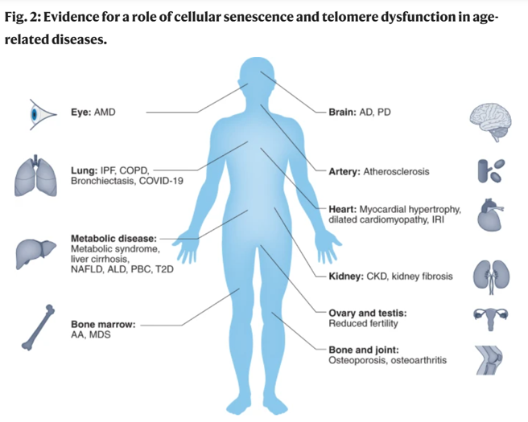

1.4 Conclusion

Currently, we don’t have proven methods to slow aging, and while caloric restriction shows promise in some species, its effects on humans remain unconfirmed. Human lifespans may be gradually increasing, but this change is so slow that we may not notice it for many generations. The society needs to treat youth and aging on par, as most aging products are ineffective. Biomedical research needs not merely to prolong life but improve the quality of life for the elderly, so they might live longer without being disabled or dependent.

Bibliography:

- Hayflick , L. (2000). The Future of Ageing. Nature.
- Rossiello, Jurk , Passos, Fagagna, F. D. J. F. ,. (2022). Telomere dysfunction in ageing and age-related diseases. Nature.
- W. H. O. (2022, October 1). Ageing and health.
- Corina A. , Inés M. , Saria C. , Yu-Jui H. , Sandeep N. , Courtenay G. , Sebastian C. , Emmanuella J. , Judith F. , Clemens Hinterleitner, Valentin J. A. Barthet, Jacob A. Boyer, Riccardo Mezzadra, Matthew G. Wereski, David A. Tuveson, Ross L. Levine, Lee W. Jones, Michel Sadelain & Scott W. Lowe (2024). Prophylactic and long-lasting efficacy of senolytic CAR T cells against age-related metabolic dysfunction. Nature.
- Pelc , C. (2024, January 31). Scientists reprogram T cells to slow down and reverse aging. Medical News Today.

